A000-AM,C-Taino-Yuke-Yoke-1000 CE

Case no. 17

According to Fewkes “Boa is the serpent and Maboya is the great serpent. Guabancex was a woman to whom the Antilleans prayed for rain. Her two assistants were her agents in bringing rain, etc. Maboya and Guabancex have many points of similarity. In their apparently tortuous method, the conclusion is arrived at that the great sky god to whom the Antilleans prayed for the success of their farming was a serpent god, not a god of evil, as early authors stated in their interpretation of Antillean mythology, but a beneficent god, although at times a ruler of the hurricane. … Porto Rican stone collars have a certain resemblance to serpents with tail bound to the neck. The collar stone united to her twin sons, and fire god, thus becomes the idol of the great beneficent serpent, Yocahú-Hura-kán, to whom the Antilleans prayed for rain or for their yuc[c]a. The other important power worshipped by the Antilleans was Mamona, or Tierra, the earth. Mother earth, the female element that produces the yuc[c]a” (Fewkes 1922: 264-265).

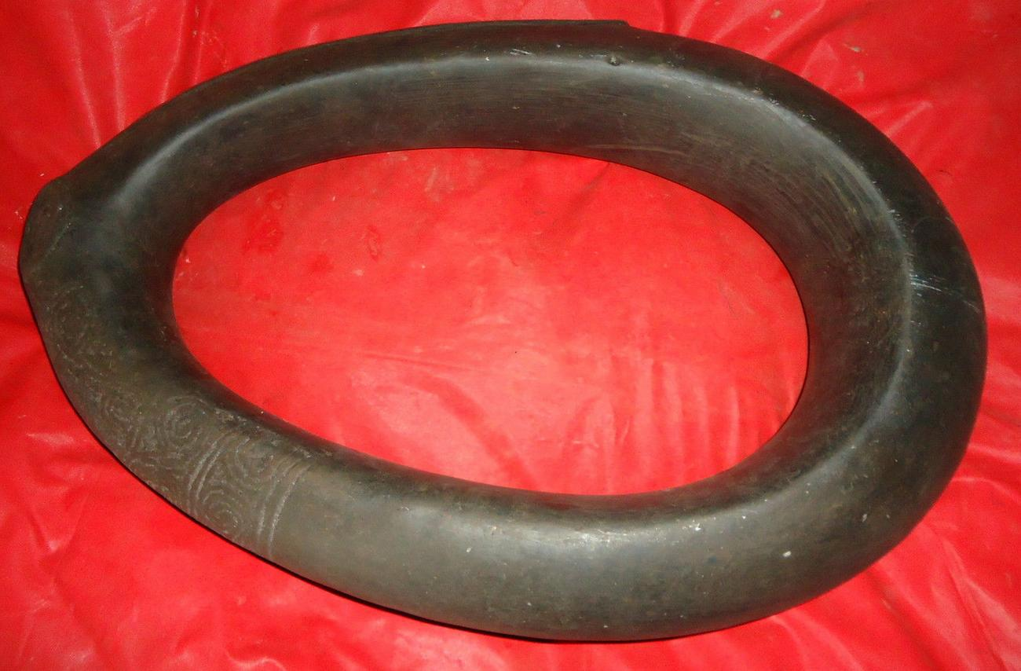

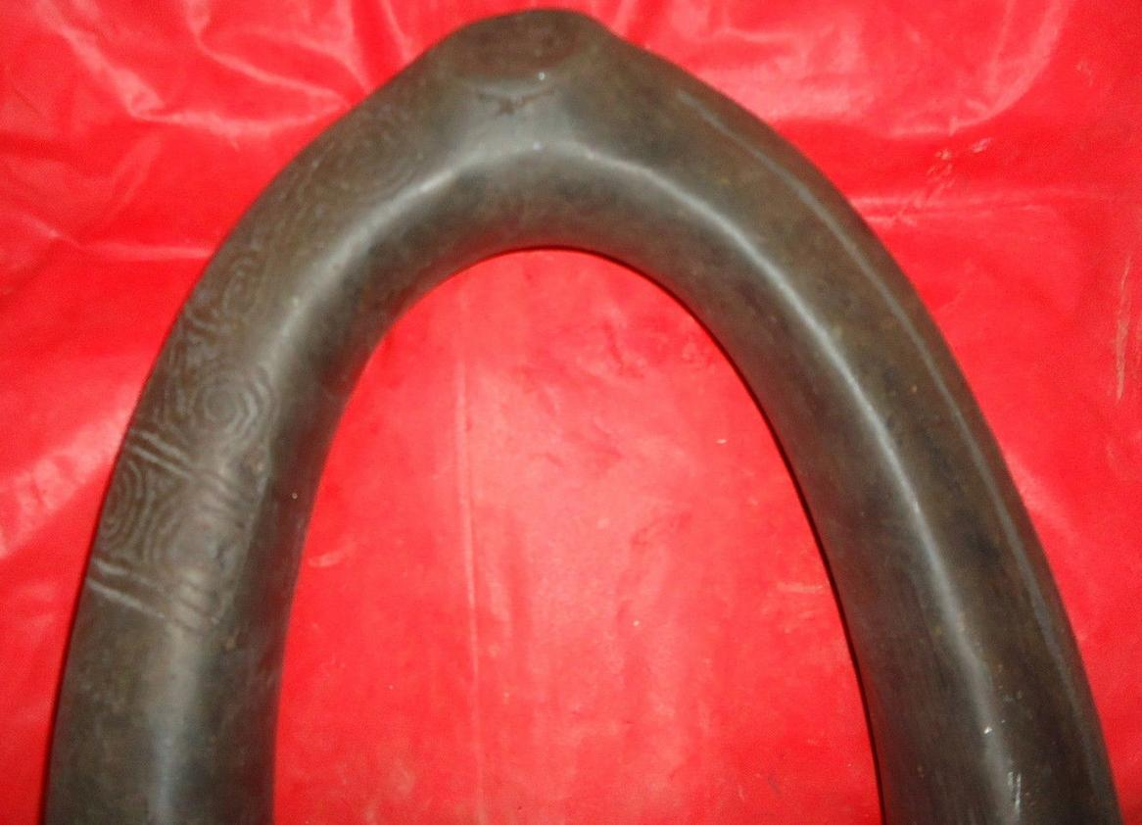

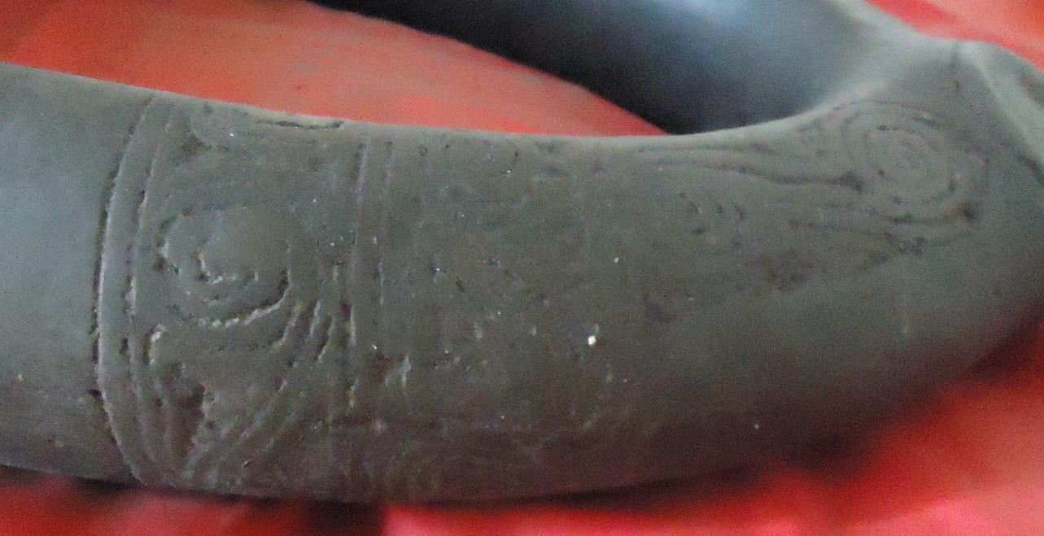

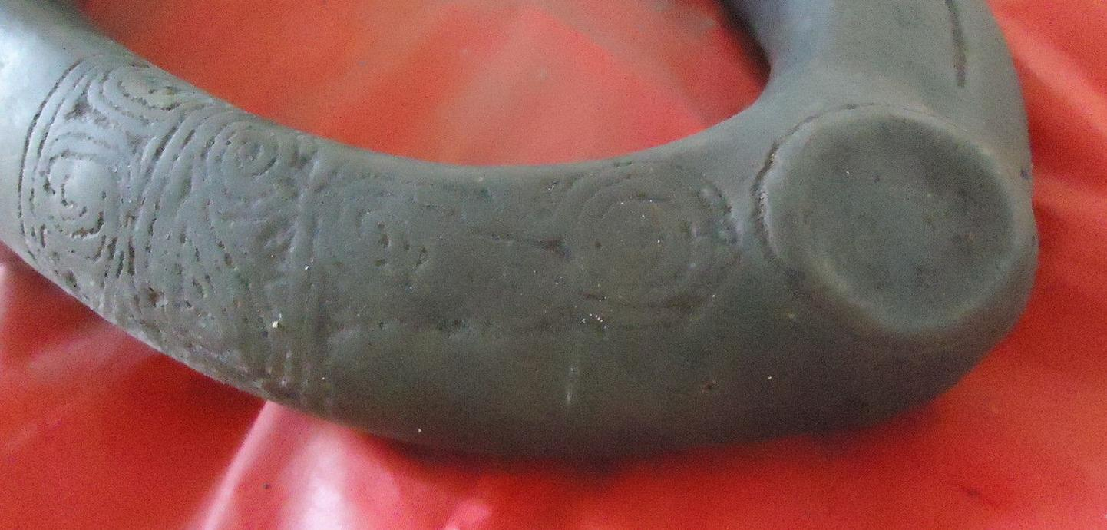

Note the boss of the solar disk, the symbol of the mother god to the right.

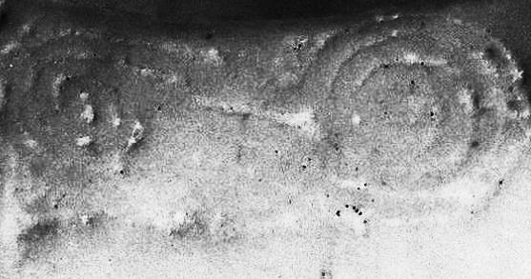

The allusion to the divine twins symbol: two concentric circles inter-connected with spirals (cf. Fernández Méndez 1972, fig 2, after Fewkes 1907.

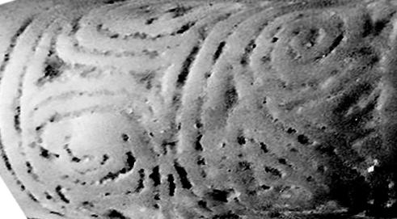

The allusion to the divine twins symbol on the right: two concentric circles inter-connected with spirals (cf. Fernández Méndez 1972, fig 2, after Fewkes 1907. Left: two opposing spirals not inter-connected.

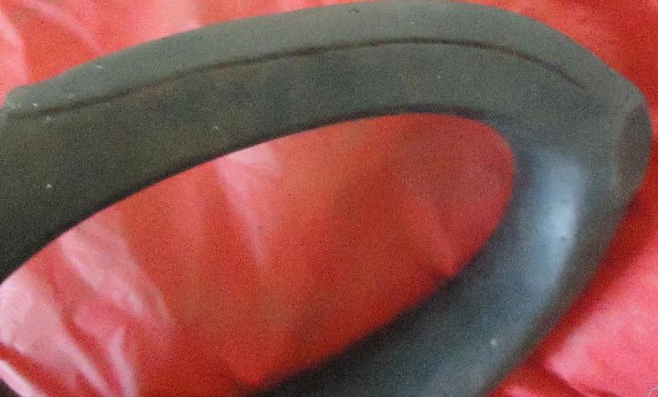

Note the overlapping flange projection suggestive of a serpent’s tail extending from the boss to the right of this slender ovate stone “collar” (cf. Fewkes 1912, Fig. 33, p. 188).

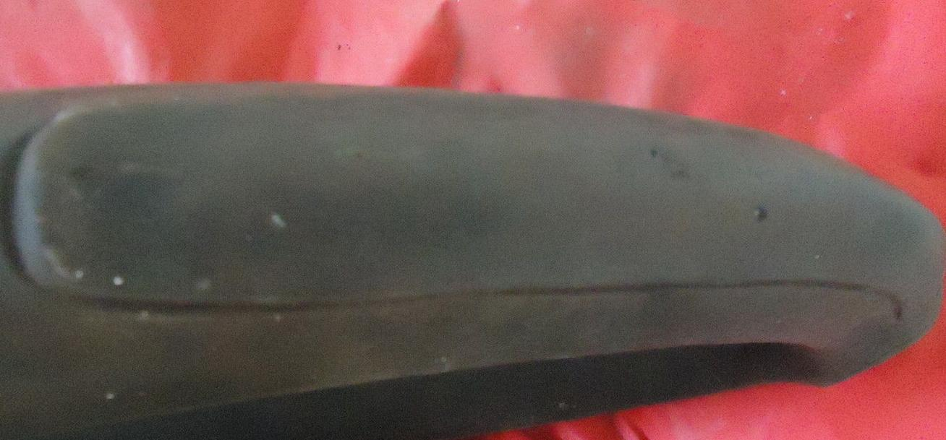

## Shipping address

Ralph J Coffman Jr

149 Atlantic Ave

Swampscott MA 01907-2427

United States

## Order total

|  |  |
| --- | --- |
| Subtotal | $1,071.94 |
| Shipping | $21.94 |

**Total**

$1,093.88